MATLAB Functions for Mie Scattering and Absorption

Christian Mätzler



Research Report No. 2002-08 June 2002

Institut für Angewandte Physik |  | Mikrowellenabteilung
Sidlerstrasse 5 | Tel. | : +41 31 631 89 11
3012 Bern | Fax. | : +41 31 631 37 65
Schweiz | E-mail | : matzler@iap.unibe.ch

MATLAB Functions for Mie Scattering and Absorption

Christian Mätzler, Institute of Applied Physics, University of Bern, June 20021

List of Contents
Abstract 1
- Introduction 2
- Formulas for a homogeneous sphere 2
  - Mie coefficients and Bessel functions 2
  - Mie efficiencies and cross sections 3
  - The scattered far field 4
  - The internal field 5
  - Computation of Q_{abs}, based on the internal field 6
- The MATLAB Programs 7
  - Comments 7
  - The Function Mie_abcd 8
  - The Function Mie 8
  - The Function Mie_S12 9
  - The Function Mie_xscan 10
  - The Function Mie_tetascan 10
  - The Function Mie_pt 11
  - The Function Mie_Esquare 11
  - The Function Mie_abs 12
- Examples and Tests 13
  - The situation of x=1, m=5+0.4i 13
  - Large size parameters 15
  - Large refractive index 16
- Conclusion, and outlook to further developments 18
References 18

Abstract
A set of Mie functions has been developed in MATLAB to compute the four Mie coefficients an, bn, cn and dn, efficiencies of extinction, scattering, backscattering and absorption, the asymmetry parameter, and the two angular scattering func- tions S1 and S2. In addition to the scattered field, also the absolute-square of the internal field is computed and used to get the absorption efficiency in a way inde- pendent from the scattered field. This allows to test the computational accuracy.
This first version of MATLAB Mie Functions is limited to homogeneous dielectric spheres without change in the magnetic permeability between the inside and out- side of the particle. Required input parameters are the complex refractive index, m= m’+ im”, of the sphere (relative to the ambient medium) and the size parameter, x=ka, where a is the sphere radius and k the wave number in the ambient medium.
1 Equation on p. 16 corrected, April 2006

Introduction
This report is a description of Mie-Scattering and Mie-Absorption programs written in the numeric computation and visualisation software, MATLAB (Math Works, 1992), for the improvement of radiative-transfer codes, especially to account for rain and hail in the microwave range and for aerosols and clouds in the submillimeter, infrared and visible range. Excellent descriptions of Mie Scattering were given by van de Hulst (1957) and by Bohren and Huffman (1983). The present programs are related to the formalism of Bohren and Huffman (1983). In addition an extension (Section 2.5) is given to describe the radial dependence of the internal electric field of the scattering sphere and the absorption resulting from this field. Except for Section 2.5, equation numbers refer to those in Bohren and Huffman (1983), in short BH, or in case of missing equation numbers, page numbers are given. For a description of computational problems in the Mie calculations, see the notes on p. 126-129 and in Appendix A of BH.

Formulas for a homogeneous sphere

Mie coefficients and Bessel functions
MATLAB function: Mie_abcd
The key parameters for Mie calculations are the Mie coefficients an and bn to com- pute the amplitudes of the scattered field, and cn and dn for the internal field, respectively. The computation of these parameters has been the most challenging part in Mie computations due to the involvement of spherical Bessel functions up to high order. With MATLAB’s built-in double-precision Bessel functions, the com- putation of the Mie coefficients has so far worked well up to size parameters exceeding 10’000; the coefficients are given in BH on p.100:
m² j (mx)[xj (x)]'−μ j (x)[mxj (mx)]'

an = ^{n}
n 1 n n

m² j (mx)[xh⁽¹⁾ (x)]'−μ h⁽¹⁾ (x)[mxj (mx)]'

n n 1 n n

(4.53)

b = μ1 jn (mx)[xjn (x)]'− jn (x)[mxjn (mx)]'

^{n} μ j (mx)[xh⁽¹⁾ (x)]'−h⁽¹⁾ (x)[mxj (mx)]'
1 n n n n

μ j (x)[xh⁽¹⁾ (x)]'−μ h⁽¹⁾ (x)[xj (x)]'

cn = 1 n n
1 n n

μ j (mx)[xh⁽¹⁾ (x)]'−h⁽¹⁾ (x)[mxj (mx)]'

1 n n n n

(4.52)

μ mj (x)[xh⁽¹⁾ (x)]'−μ mh⁽¹⁾ (x)[xj (x)]'

dn = 1 n n
1 n n

m² j (mx)[xh⁽¹⁾ (x)]'−μ h⁽¹⁾ (x)[mxj (mx)]'
n n 1 n n
where m is the refractive index of the sphere relative to the ambient medium, x=ka is the size parameter, a the radius of the sphere and k =2υ/λ is the wave number and λ the wavelength in the ambient medium. In deviation from BH, μ1 is the ratio of the magnetic permeability of the sphere to the magnetic permeability of the ambient medium (corresponding to μ1/μ in BH). The functions jn(z) and
h⁽¹⁾ (z) =jn(z)+iyn(z) are spherical Bessel functions of order n (n= 1, 2,..) and of the given arguments, z= x or mx, respectively, and primes mean derivatives with respect to the argument. The derivatives follow from the spherical Bessel functions them-
n
selves, namely

[zj (z)]'= zj (z) − nj (z); [zh⁽¹⁾ (z)]'= zh⁽¹⁾ (z) − nh⁽¹⁾ (z)

(p.127)

n n −1 n n n −1 n

For completeness, the following relationships between Bessel and spherical Bessel functions are given:
υ
2z

jn (z) =
Jn + 0.5
(z)

(4.9)

y (z) = υ Y
(z)

(4.10)

n 2z n + 0.5
Here, J_{ϖ} and Y_{ϖ} are Bessel functions of the first and second kind. For n=0 and 1 the spherical Bessel functions are given (BH, p. 87) by
2
j₀ (z) = sin z / z; j (z) = sin z / z − cos z / z
1
y (z) = −cos z / z; y (z) = −cos z / z² − sin z / z
0 1
and the recurrence formula

fn −1
(z) + f

n +1
(z) = 2n + 1 f
z n

(z)

(4.11)

where fn is any of the functions jn and yn. Taylor-series expansions for small argu- ments of jn and yn are given on p. 130 of BH. The spherical Hankel functions are linear combinations of jn and yn. Here, the first type is required

h⁽¹⁾ (z) = j (z) + iy (z)

(4.13)

n n n
The following related functions are also used in Mie theory (although we try to avoid them here):

ʩ n (z) = zjn (z);
χn (z) = −zyn
(z);
) (z) = zh⁽¹⁾ (z)

(p.101, 183)

Often μ1=1; then, (4.52-4.53) simplify to
n
n
m² j (mx)[xj (x)]'− j (x)[mxj (mx)]'
an = n n n n ;
m² j (mx)[xh⁽¹⁾ (x)]'−h⁽¹⁾ (x)[mxj (mx)]'
n n n n

bn =
jn (mx)[xjn (x)]'− jn (x)[mxjn (mx)]'

j (mx)[xh⁽¹⁾ (x)]'−h⁽¹⁾ (x)[mxj (mx)]'

n n n n

j (x)[xh⁽¹⁾ (x)]'−h⁽¹⁾ (x)[xj (x)]'

cn = n n
n n ;

j (mx)[xh⁽¹⁾ (x)]'−h⁽¹⁾ (x)[mxj (mx)]'
n n n n
mj (x)[xh⁽¹⁾ (x)]'−mh⁽¹⁾ (x)[xj (x)]'
dn = n n n n

m² j (mx)[xh⁽¹⁾ (x)]'−h⁽¹⁾ (x)[mxj (mx)]'
n n n n
The parameters used in radiative transfer depend on an and bn, but not on cn and dn. The latter coefficients are needed when the electric field inside the sphere is of interest, e.g. to test the field penetration in the sphere, to study the distribution of heat sources or to compute absorption. The absorption efficiency Qabs, however, can also be computed from the scattered radiation, Equations (3.25), (4.61-62) to be shown below.

Mie efficiencies and cross sections
MATLAB functions: Mie, Mie_xscan

The efficiencies Qi for the interaction of radiation with a scattering sphere of radius a are cross sections σi (called Ci in BH) normalised to the particle cross section, υa2, where i stands for extinction (i=ext), absorption (i=abs), scattering (i=sca), back- scattering (i=b), and radiation pressure (i=pr), thus
Q = σi

^{i} υ a²

Energy conservation requires that

Qext
= Qsca + Qabs , or σext = σ sca + σ abs

(3.25)

The scattering efficiency Qsca follows from the integration of the scattered power over all directions, and the extinction efficiency Qext follows from the Extinction Theorem (Ishimaru, 1978, p. 14, van de Hulst, 1957, p. 31), also called Forward-Scattering Theorem, leading to:
Q 2 ∞ 2 2

_{sca} = 2 ∑(2n + 1)( an
x
n =1
- bn )

(4.61)

2 ∞

Q

_{ext} = 2 ∑(2n + 1) Re(an + bn )
x
n =1

(4.62)

and Qabs follows from (3.25). All infinite series can be truncated after nmax terms. For this number Bohren and Huffman (1983) proposed the value

n = x + 4x^{1/} ³ + 2
max
and this value is used here as well. Furthermore, the asymmetry parameter g=

cosθ

(p.477)
indicates the average cosine of

the scattering angle θ with respect to power; it is used in Two-Stream Models (Mea- dor and Weaver, 1980), and it is related to the efficiency Qpr of radiation pressure:

Qpr = Qext − Qsca

cosθ

(p.120)

Q cos

4 ⎧ ∞
n(n + 2) Re(a a*
b b* )
∞ 2n + 1
Re(a b*)⎫

sca
θ = 2 ⎨∑
⎩n =1
x
n + 1
n n +1 + n
n +1
- ∑ n(n + 1)
n n ⎬
⎭

Finally, the backscattering efficiency Qb, applicable to monostatic radar, is given by
n =1

Qb =

∞
∑(2n + 1)(−1)^{n} (a
1
x2
n
n =1
2
− bn )

(p.122)

The scattered far field
MATLAB functions: Mie_S12, Mie_pt, Mie_tetascan
If the detailed shape of the angular scattering pattern is required, e.g. to get the phase matrix or phase function for radiative-transfer calculations (Chandrasekhar, 1960), the scattering functions S1 and S2 are required. These functions describe the scattered field E_{s}. The scattered far field in spherical coordinates (E_{sθ}, E_{sφ}) for a unit- amplitude incident field (where the time variation exp(-iωt) has been omitted) is given by

Esθ
eikr
= − ikr
eikr

cosφ ⋅ S₂ (cosθ )

(p.111)

Esφ = ikr sinφ ⋅ S1 (cosθ )
with the scattering amplitudes S1 and S2

S (cos )
∞ 2n +1 (a

b );

1 θ = ∑ n(n +1)
n=1
nυ n +
nυ n

(4.74)

∞ 2n +1
S (cos ) (a b )
2 θ = ∑ n(n +1) ^{n}υn + nυ n
n=1
E_{sθ} is the scattered far-field component in the scattering plane, defined by the inci- dent and scattered directions, and E_{sφ} is the orthogonal component. The angle φ is the angle between the incident electric field and the scattering plane. The functions
υn(cosθ) and υn(cosθ) describe the angular scattering patterns of the spherical har-
monics used to describe S1 and S2 and follow from the recurrence relations
2n −1 n
υ n = n − 1 cosθ ⋅υ n −1 − n − 1υn − 2 ; υn = n cosθ ⋅υ n − (n + 1)υ n −1 (4.47)
starting with (Deirmendjian, 1969, p. 15)

υ 0 = 0; υ1 = 1; υ 2 = 3cosθ ; υ 0 = 0; υ1 = cosθ ; υ 2 = 3cos(2θ )

The internal field
MATLAB function: presently, no direct function, but see Mie_Esquare
The internal field E1 for an incident field with unit amplitude is given by

E ∞ 2n + 1) (c M(1)
n =1
d N(1) )

(4.40)

1 = ∑ n(n + 1) n o1n − n e1n
where the vector-wave harmonic fields are given in spherical (r,θ,φ) coordinates by

(1)
M
o1n
& 0
⎮

= ⎮ cosφ ⋅∗
⎞
⎮
_{n} (cosθ ) jn (rmx) ⎮

⎮ − sin φ ⋅,n (cosθ ) jn (rmx)⎮
⎠
⎛
& n(n +1) cosφ ⋅ sinθ ⋅∗ (cosθ ) jn (rmx) ⎞

(1)
N
e1n
⎮
⎮

= ⎮ cosφ ⋅,
⎮
n
n

(cosθ ) [rmxjn (rmx)]'

rmx
rmx ⎮
⎮
⎮
⎮

(4.50)

⎮

⎮ − sin φ ⋅∗
⎮
⎛
⎮
(cosθ ) [rmxjn (rmx)]' ⎮
n ⎮

rmx ⎠

and the coordinate system is defined as for the scattered field. The vector-wave functions N and M are orthogonal with respect to integration over directions. Fur- thermore for different values of n, the N functions are orthogonal, too, and the same is true for the M functions.

Computation of Qabs, based on the internal field
MATLAB functions: Mie_Esquare, Mie_abs
The absorption cross section of a particle with dielectric (i.e. Ohmic) losses is given by (Ishimaru, 1978, p. 17)

σ = kε" E
²dV
(1)

abs ∫ 1
V
where ε” is the imaginary part of the relative dielectric constant of the particle (here with respect to the ambient medium). Thanks to the orthogonality of the spherical vector-wave functions this integral becomes in spherical coordinates

∞ +1
2 ( 2 2 )

σ abs = kε"υ ∑ ∫ d (cosθ )∫ r
a
n =1 −1 0
dr cn
(mθ + mφ ) + dn
(nr + nθ + nφ )
(2)

and the integration over azimuth φ has already been performed, leading to the fac- tor υ. The functions in the integrand are absolute-square values of the series terms of the components of the vector-waves (4.50)
m = g υ ² (cosθ ) ⋅ j (z) ²
θ n n n
m = g υ ² (cosθ ) ⋅ j (z) ²

φ n n
n
j (z) ²

n = g sin² θ ⋅υ ² (cosθ ) ^{n}
(3)

r n n z
(zj (z))' ²
n = g υ ² (cosθ ) ^{n}

θ n n
z
(zj (z))' ²

n = g υ ² (cosθ ) ^{n}
φ n n z

Here z=mrk, and gn stands for
2

& 2n + 1 ⎞
gn = ⎮ n(n + 1) ⎮

(4)

⎛ ⎠
For the integrals over cosθ, analytic solutions can be obtained. First, from BH we find

1

(υ ² (cosθ ) +υ ² (cosθ ))d (cosθ ) =
2n² (n +1)²

(p.103)

∫ n n
−1

2n +1

and second, from (4.46) in BH and Equation 8.14.13 of Abramowitz and Stegun (1965), we get

1

(sin² θ ⋅υ ² (cosθ ))d (cosθ ) =
(P¹(cosθ ))2 d (cosθ ) = 2(n +1)

(5)

∫ n ∫ n
1
−1 −1
2n +1

leading to the two parts (6) and (7) of the angular integral in (2)
n

mn =
1
∫(mθ
−1

- mφ
)d (cosθ ) = 2(2n + 1) j (z) ²

(6)

1 ⎧⎮
j (z) ²
(zj (z))' 2 ⎫⎮

nn =
(nr + n + n )d (cosθ ) = 2n(2n + 1)⎨(n + 1) ^{n}
  - n ⎬
(7)

∫ θ φ
−1
⎮⎩ z
z ⎮⎭

Now, the absorption cross section follows from integration over the radial distance r
inside the sphere up to the sphere radius a:
( 2 2 ) 2
a
∞

σ abs = kε"υ ∑∫ mn cn
n =1 0
  - nn dn
⋅ r dr
(8)

The integrand contains the radial dependence of the absolute-square electric field
E ² averaged over spherical shells (all θ and φ, constant r):

E 2 1
(m c ²
n d ² )
(9)

= ∑
4
∞
n=1
n n + n n

and in terms of this quantity, the absorption efficiency becomes

4ε " ^{x}
Qabs = 2 ∫
x
0

E ² x'² dx'

(10)

where x’=rk=z/m. Note that (9) is dimensionless because of the unit-amplitude incident field; In case of Rayleigh scattering (x<<1) the internal field is constant, and the corresponding squared-field ratio (9) is given by

9 (11)
m² + 2
2

This quantity can be used to test the accuracy of the function, Mie_Esquare, for small size parameters. In addition, Equation (10) can be used to test the accuracy of the computation of Qabs from the difference, Qext –Qsca (4.61-62). Finally, it should be remembered that all infinite series can be terminated after nmax terms.

The MATLAB Programs

Comments
    - Restrictions
- The present restrictions are situations with μ1=1; this means that the permittiv- ity of the sphere relative to the ambient medium is given by ε=m2.
- There is a maximum x value for stable and correct computation of Mie scatter- ing. For a small or moderate imaginary refractive index m”, the maximum size parameter ranges somewhere between 104 and 105, however, for m”>>1, the maximum size parameter is strongly diminished.

    - Computation of Bessel Functions
The ordinary Bessel Functions J_{ϖ}(z) and Y_{ϖ}(z) are standard functions in MATLAB. The spherical Bessel Functions used here follow from (4.9-10) of BH.
    - Computation of angular functions
The angular functions, υn and υn, are computed from the recurrence relations (4.47) of BH with the initial functions given for n=1 and 2.

    - Optimisation strategy
The programs were optimised rather with respect to computation speed than memory space; all required function values are computed only once and then stored for further use in vectors of dimension nmax.

The Function Mie_abcd
The following text lists the basic program to compute the Mie Coefficients an, bn, cn, dn and to produce a matrix of nmax column vectors [an; bn; cn; dn]:

function result = Mie_abcd(m, x)

% Computes a matrix of Mie coefficients, a_n, b_n, c_n, d_n,
% of orders n=1 to nmax, complex refractive index m=m'+im",
% and size parameter x=k0*a, where k0= wave number
% in the ambient medium, a=sphere radius;
% p. 100, 477 in Bohren and Huffman (1983) BEWI:TDD122
% C. Mätzler, June 2002

nmax=round(2+x+4*x^(1/3));
n=(1:nmax); nu = (n+0.5); z=m.*x; m2=m.*m; sqx= sqrt(0.5*pi./x); sqz= sqrt(0.5*pi./z);
bx = besselj(nu, x).*sqx; bz = besselj(nu, z).*sqz; yx = bessely(nu, x).*sqx; hx = bx+i*yx;
b1x=[sin(x)/x, bx(1:nmax-1)];
b1z=[sin(z)/z, bz(1:nmax-1)];
y1x=[-cos(x)/x, yx(1:nmax-1)]; h1x= b1x+i*y1x;
ax = x.*b1x-n.*bx; az = z.*b1z-n.*bz; ahx= x.*h1x-n.*hx;
an = (m2.*bz.*ax-bx.*az)./(m2.*bz.*ahx-hx.*az);
bn = (bz.*ax-bx.*az)./(bz.*ahx-hx.*az);
cn = (bx.*ahx-hx.*ax)./(bz.*ahx-hx.*az);
dn = m.*(bx.*ahx-hx.*ax)./(m2.*bz.*ahx-hx.*az); result=[an; bn; cn; dn];

The Function Mie
The following text lists the Program to compute the Mie Efficiencies: function result = Mie(m, x)
% Computation of Mie Efficiencies for given
% complex refractive-index ratio m=m'+im"
% and size parameter x=k0*a, where k0= wave number in ambient
% medium, a=sphere radius, using complex Mie Coefficients
% an and bn for n=1 to nmax,
% s. Bohren and Huffman (1983) BEWI:TDD122, p. 103,119-122,477.
% Result: m', m", x, efficiencies for extinction (qext),
% scattering (qsca), absorption (qabs), backscattering (qb),
% asymmetry parameter (asy=<costeta>) and (qratio=qb/qsca).

% Uses the function "Mie_abcd" for an and bn, for n=1 to nmax.
% C. Mätzler, May 2002.

if x==0 % To avoid a singularity at x=0 result=[real(m) imag(m) 0 0 0 0 0 0 1.5];
elseif x>0 % This is the normal situation nmax=round(2+x+4*x^(1/3));
n1=nmax-1;
n=(1:nmax);cn=2*n+1; c1n=n.*(n+2)./(n+1); c2n=cn./n./(n+1); x2=x*x;
f=mie_abcd(m,x);
anp=(real(f(1,:))); anpp=(imag(f(1,:)));
bnp=(real(f(2,:))); bnpp=(imag(f(2,:)));
g1(1:4,nmax)=[0; 0; 0; 0]; % displaced numbers used for g1(1,1:n1)=anp(2:nmax); % asymmetry parameter, p. 120 g1(2,1:n1)=anpp(2:nmax);
g1(3,1:n1)=bnp(2:nmax);
g1(4,1:n1)=bnpp(2:nmax); dn=cn.*(anp+bnp); q=sum(dn);
qext=2*q/x2; en=cn.*(anp.*anp+anpp.*anpp+bnp.*bnp+bnpp.*bnpp); q=sum(en);
qsca=2*q/x2; qabs=qext-qsca; fn=(f(1,:)-f(2,:)).*cn; gn=(-1).^n;
f(3,:)=fn.*gn;
q=sum(f(3,:)); qb=q*q'/x2;
asy1=c1n.*(anp.*g1(1,:)+anpp.*g1(2,:)+bnp.*g1(3,:)+bnpp.*g1(4,:)); asy2=c2n.*(anp.*bnp+anpp.*bnpp); asy=4/x2*sum(asy1+asy2)/qsca;
qratio=qb/qsca;
result=[real(m) imag(m) x qext qsca qabs qb asy qratio]; end;

The Function Mie_S12
The following text lists the program to compute the two complex scattering ampli- tudes S1 and S2:

function result = Mie_S12(m, x, u)

% Computation of Mie Scattering functions S1 and S2
% for complex refractive index m=m'+im",
% size parameter x=k0*a, and u=cos(scattering angle),
% where k0=vacuum wave number, a=sphere radius;
% s. p. 111-114, Bohren and Huffman (1983) BEWI:TDD122
% C. Mätzler, May 2002

nmax=round(2+x+4*x^(1/3)); abcd=Mie_abcd(m,x); an=abcd(1,:);

bn=abcd(2,:); pt=Mie_pt(u,nmax); pin =pt(1,:);
tin=pt(2,:);
n=(1:nmax); n2=(2*n+1)./(n.*(n+1)); pin=n2.*pin; tin=n2.*tin; S1=(an*pin'+bn*tin'); S2=(an*tin'+bn*pin'); result=[S1;S2];

The Function Mie_xscan
The following text lists the program to compute the a matrix of Mie efficiencies and to plot them as a function of x:

function result = Mie_xscan(m, nsteps, dx)

% Computation and plot of Mie Efficiencies for given
% complex refractive-index ratio m=m'+im"
% and range of size parameters x=k0*a,
% starting at x=0 with nsteps increments of dx
% a=sphere radius, using complex Mie coefficients an and bn
% according to Bohren and Huffman (1983) BEWI:TDD122
% result: m', m", x, efficiencies for extinction (qext),
% scattering (qsca), absorption (qabs), backscattering (qb),
% qratio=qb/qsca and asymmetry parameter (asy=<costeta>).
% C. Mätzler, May 2002.

nx=(1:nsteps)';
x=(nx-1)*dx; for j = 1:nsteps
a(j,:)=Mie(m,x(j)); end;
output_parameters='Real(m), Imag(m), x, Qext, Qsca, Qabs, Qb, <costeta>, Qb/Qsca'
m1=real(m);m2=imag(m);
plot(a(:,3),a(:,4:9)) % plotting the results legend('Qext','Qsca','Qabs','Qb','<costeta>','Qb/Qsca') title(sprintf('Mie Efficiencies, m=%g+%gi',m1,m2))
xlabel('x') result=a;

The Function Mie_tetascan
The following text lists the program to compute the a matrix of Mie scattering
intensities S 2 and as a function of u=cosθ, and to display the result as a
1
S
2
2
2
S
2
S
polar diagram of θ with ₁ in the upper half circle (0<θ<υ) and in the lower
2
half circle (υ<θ<2υ). Both functions are symmetric with respect to both half circles: function result = Mie_tetascan(m, x, nsteps)

% Computation and plot of Mie Power Scattering function for given
% complex refractive-index ratio m=m'+im", size parameters x=k0*a,
% according to Bohren and Huffman (1983) BEWI:TDD122
% C. Mätzler, May 2002.

nsteps=nsteps; m1=real(m); m2=imag(m);
nx=(1:nsteps); dteta=pi/(nsteps-1); teta=(nx-1).*dteta;
for j = 1:nsteps, u=cos(teta(j)); a(:,j)=Mie_S12(m,x,u);
SL(j)= real(a(1,j)'*a(1,j));
SR(j)= real(a(2,j)'*a(2,j)); end;
y=[teta teta+pi;SL SR(nsteps:-1:1)]'; polar(y(:,1),y(:,2))
title(sprintf('Mie angular scattering: m=%g+%gi, x=%g',m1,m2,x)); xlabel('Scattering Angle')
result=y;

The Function Mie_pt
The following text lists the program to compute a matrix of υn and υn functions for
n=1 to nmax:

function result=Mie_pt(u,nmax)

% pi_n and tau_n, -1 <= u= cosθ <= 1, n1 integer from 1 to nmax
% angular functions used in Mie Theory
% Bohren and Huffman (1983), p. 94 - 95

p(1)=1;
t(1)=u;
p(2)=3*u; t(2)=3*cos(2*acos(u)); for n1=3:nmax,
p1=(2*n1-1)./(n1-1).*p(n1-1).*u; p2=n1./(n1-1).*p(n1-2); p(n1)=p1-p2;
t1=n1*u.*p(n1); t2=(n1+1).*p(n1-1);
t(n1)=t1-t2; end; result=[p;t];

The Function Mie_Esquare
The following text lists the program to compute and plot the (θ, φ) averaged
absolute-square E-field as a function of x’=rk (for r<0<a): function result = Mie_Esquare(m, x, nj)

% Computation of nj+1 equally spaced values within (0,x)
% of the mean-absolute-square internal
% electric field of a sphere of size parameter x,
% complex refractive index m=m'+im",
% where the averaging is done over teta and phi,
% with unit-amplitude incident field;
% Ref. Bohren and Huffman (1983) BEWI:TDD122,
% and my own notes on this topic;
% k0=2*pi./wavelength;
% x=k0.*radius;
% C. Mätzler, May 2002

nmax=round(2+x+4*x^(1/3)); n=(1:nmax); nu =(n+0.5); m1=real(m); m2=imag(m); abcd=Mie_abcd(m,x); cn=abcd(3,:);dn=abcd(4,:); cn2=abs(cn).^2; dn2=abs(dn).^2;
dx=x/nj; for j=1:nj,
xj=dx.*j; z=m.*xj;
sqz= sqrt(0.5*pi./z);
bz = besselj(nu, z).*sqz; % This is jn(z) bz2=(abs(bz)).^2;
b1z=[sin(z)/z, bz(1:nmax-1)]; % Note that sin(z)/z=j0(z) az = b1z-n.*bz./z;
az2=(abs(az)).^2;
z2=(abs(z)).^2; n1 =n.*(n+1);
n2 =2.*(2.*n+1);
mn=real(bz2.*n2); nn1=az2; nn2=bz2.*n1./z2; nn=n2.*real(nn1+nn2);
en(j)=0.25*(cn2*mn'+dn2*nn'); end;
xxj=[0:dx:xj]; een=[en(1) en]; plot(xxj,een);
legend('Radial Dependence of (abs(E))^2')
title(sprintf('Squared Amplitude E Field in a Sphere, m=%g+%gi x=%g',m1,m2,x)) xlabel('r k')
result=een;

The Function Mie_abs
The following text lists the program to compute the absorption efficiency, based on Equation (9):

function result = Mie_abs(m, x)

% Computation of the Absorption Efficiency Qabs
% of a sphere of size parameter x,

% complex refractive index m=m'+im",
% based on nj internal radial electric field values
% to be computed with Mie_Esquare(nj,m,x)
% Ref. Bohren and Huffman (1983) BEWI:TDD122,
% and my own notes on this topic;
% k0=2*pi./wavelength;
% x=k0.*radius;
% C. Mätzler, May 2002

nj=5*round(2+x+4*x.^(1/3))+160; e2=imag(m.*m);
dx=x/nj; x2=x.*x; nj1=nj+1; xj=(0:dx:x);
en=Mie_Esquare(m,x,nj);
en1=0.5*en(nj1).*x2; % End-Term correction in integral enx=en*(xj.*xj)'-en1; % Trapezoidal radial integration inte=dx.*enx;
Qabs=4.*e2.*inte./x2; result=Qabs;

Examples and Tests

The situation of x=1, m=5+0.4i
The execution of the command line
>> m =5 + 0.4i; x = 1; mie_abcd(m,x)

leads to column vectors [an; bn; cn; dn] for n=1 to nmax=7: ans =
Columns 1 through 4 (for n=1 to 4)

0.2306 - 0.2511i 0.0055 - 0.0354i 0.0000 - 0.0008i 0.0000 - 0.0000i
0.0627 + 0.1507i 0.0159 + 0.0262i 0.0004 - 0.0006i 0.0000 - 0.0000i
-0.6837 + 0.0128i -0.3569 + 0.2199i 0.0752 + 0.0339i 0.0076 + 0.0000i
-1.1264 + 0.0093i 0.2135 + 0.1212i 0.0180 + 0.0003i 0.0023 - 0.0004i

Columns 5 through 7 (for n=5 to 7)

0.0000 - 0.0000i 0.0000 - 0.0000i 0.0000 - 0.0000i
0.0000 - 0.0000i 0.0000 - 0.0000i 0.0000 - 0.0000i
0.0010 - 0.0002i 0.0002 - 0.0000i 0.0000 - 0.0000i
0.0003 - 0.0001i 0.0001 - 0.0000i 0.0000 - 0.0000i

>> mie(m,x) ans =
Columns 1 through 7 (for m’, m”, x, Qext, Qsca, Qabs, Qb)

5.0000 0.4000 1.0000 1.9794 0.8795 1.0999 1.1138

Columns 8 through 9 (for <cosθ>, Qb/Qsca)

-0.0595 1.2664

To test the absorption efficiency, call Mie_abs:

>> Mie_abs(m,x) ans =
1.0999

to confirm the result of mie(m,x), s. above.
Mie Efficiencies are plotted versus x (0≤x≤2) by Mie_xscan(m,201,0.01) in Fig. 1. Two absorption peaks can be observed near x=0.6 and 0.85 and a rapid variation of the scattering behaviour between the forward and backward hemisphere.
To plot the angular dependence of the scattered power in the two polarisations, the function Mie_tetascan(m,x,201), for x=1, is used to provide Figure 2.
Furthermore the absolute-square internal field is plotted versus the radial distance in Figure 3 by calling Mie_Esquare (automatically called by Mie_abs).

Mie Efficiencies, m=5+0.4i
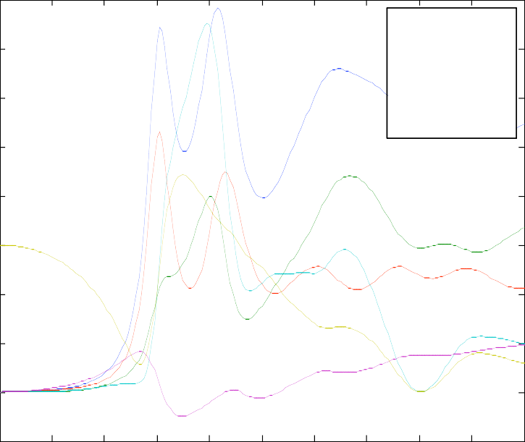
4
Qext
Qsca
Qabs
Qb
<costeta>
Qb/Qsca

3.5

3

2.5

2

1.5

1

0.5

Figure 1: Mie Efficiencies for m=5+0.4i versus x, output of the function, Mie_xscan. Note the sign of <cosθ> changes a few times between x≅ 0.6 and 1.1.

0

-0.5
0 0.2 0.4 0.6 0.8 1 1.2 1.4 1.6 1.8 2

Mie angular scattering: m=5+0.4i, x=1
90 0.4

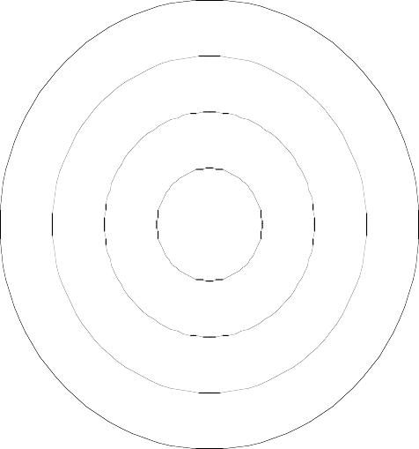
Figure 2: Angular Mie-scattering dia-
120
60
0.3
150
0.2
30
0.1
210
330
240
300
gram of 2 (upper Half circle) and of
S
1
² (lower half circle). Here, scatter-
S
2

180 0
ing in the backward hemisphere is slightly larger than in the forward hemisphere (<cosθ> <0), a situation mostly restricted to the region near x=1.

270

1.4
Radial Dependence of (abs(E))²

1.2

1

0.8
Squared Amplitude E Field in a Sphere, m=5+0.4i, x=1

Figure 3: Radial variation of the ratio of the internal/external absolute- square electric field with parameters given in the figure title. Here, the field is concentrated in the sphere centre.

0.6

0.4

0.2

0
0 0.1 0.2 0.3 0.4 0.5 0.6 0.7 0.8 0.9 1

To test the behaviour at low x values, Figure 1 indicates that the ratio Qb/Qsca approaches 1.5 near x=0. This is exactly the value obtained for Rayleigh scattering (Ishimaru, 1978). For x=0.1 Equation (9) gives absolute square internal field values between 0.0130 in the sphere centre and 0.0137 at the sphere surface, and for decreasing x the absolute square internal field of 0.0122 of the Rayleigh Expression
(11) is reached at x=0.01. This means that the validity of the Rayleigh Approxima- tion is quite limited, especially for large values of m.

Large size parameters
For x>>1, a large number of spherical harmonics have to be computed. Here we consider the example of m=2+0.01i. Figure 4 shows the Mie Efficiencies over the x range from 0 to 25. As a result of the Extinction Paradox (van de Hulst, 1957), Qext approaches the value 2 for very large x. The computed values are slightly higher in Figure 4. For increasing x, Qext decreases to 2.09 at x=100, to 2.01 at x=2800 and to Qext=2.0014 for x=40’000. The program still works at x=70'000 (Qext =2.0012), but for x>80'000 NaN values are returned.

In addition, for x>>1, the backscatter efficiency Qb should approach the geometri- cal-optics expression
m −1 2
Qb =
m + 1
which is 0.1111 in the present case. With m=2+0.01i, this value is obtained from the Function Mie for x > 300.

Mie Efficiencies, m=2+0.01i
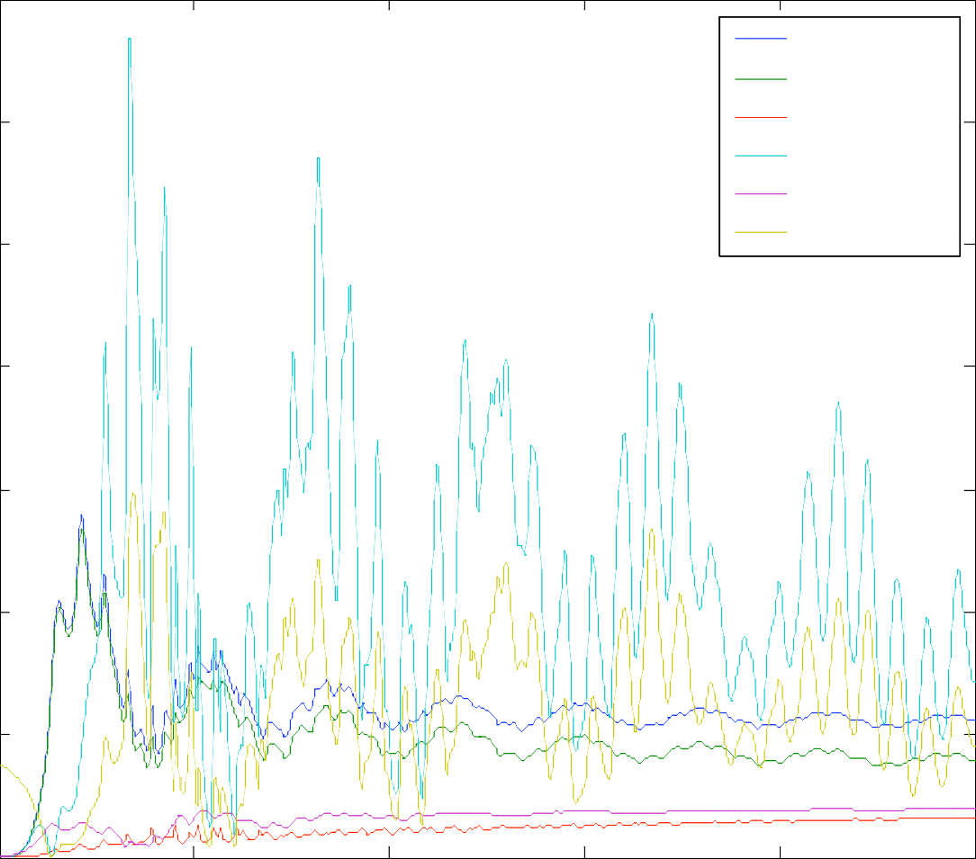
14
Qext Qsca Qabs Qb
<costeta> Qb/Qsca

12

10

8

6

4

2

0
0 5 10 15 20 25
Figure 4: Mie Efficiencies for m=2+0.01i over the x range from 0 to 25. The parameter with the maximum values and with the largest fluctuations is Qb. The curves of Qext and Qsca follow each other closely near values of 2. The lowest curve shows Qabs, and <cosθ> approaches 1 for high x values.

Large refractive index
Problems arise for high values of m. This situation occurs for metallic spheres, e.g. if m=50+50i, the maximum size parameter is about 13, and this value decreases with increasing m. A plot of efficiencies with m=50+50i is shown in Figure 5, and the radial dependence of the absolute-square E field is shown in Figure 6 for x =0.5; the skin effect is very pronounced already at this small x value. Furthermore, due to

the acting depolarisation field, the internal field is very small even at the sphere surface.

Mie Efficiencies, m=50+50i
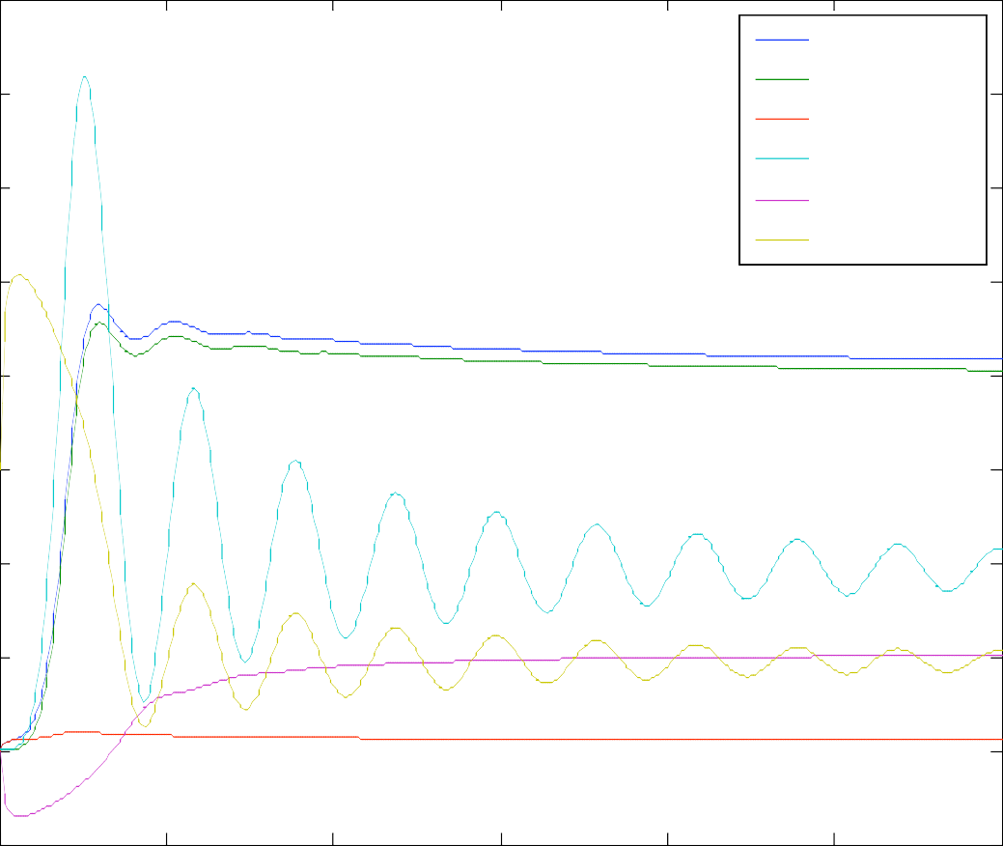
4
Qext Qsca Qabs Qb
<costeta> Qb/Qsca

3.5

3

2.5

2

1.5

1

0.5

0

-0.5
0 2 4 6 8 10 12
Figure 5: Mie efficiencies for a metal-like material (m=50+50i).

3.5

3

2.5

2

1.5
x 10-4 Squared Amplitude E Field in a Sphere, m=50+50i, x=0.5

Figure 6: Radial variation of the ratio of the internal/external ab- solute-square electric field for m=50+50i, x=0.5. The skin effect is clearly indicated by the con- centration of the field near the sphere surface.

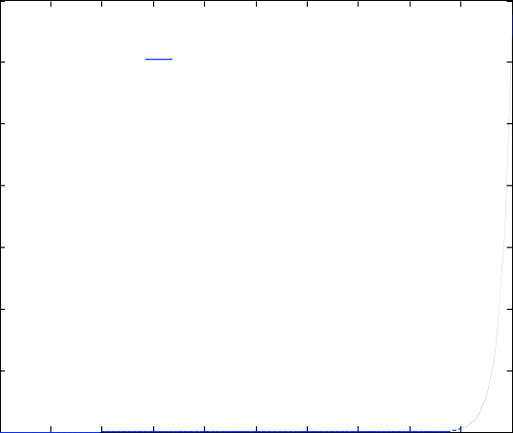
1
Radial Dependence of (abs(E))2

0.5

0
0 0.05 0.1 0.15 0.2 0.25 0.3 0.35 0.4 0.45 0.5

Conclusion, and outlook to further developments

The presented software represents the first major programming effort by the author in MATLAB; therefore the programs may not yet be optimum. Nevertheless, no severe problems have been encountered so far. Indeed, MATLAB appears to be a very efficient and accurate computing language suitable for the present application. However, further tests are required to get a more complete assessment of the Mie functions. Improvements are required to allow Mie computations for metal-like spheres over a larger x range than is presently possible.
Concerning further developments, the extension to situations with μ1,1 is straight- forward. Furthermore, it would be nice to make better use of the existing MATLAB visualisation tools. Finally, an extension to include scattering on coated spheres (BH, Section 8.1) and on other particles should be done as well.

References
Abramowitz M. and I.A. Stegun (eds.), “Handbook of Mathematical Functions”, Dover Publication, New York, NY (1965).
Bohren C.F. and D.R. Huffman, “Absorption and Scattering of Light by Small Particles”, John Wiley, New York, NY (1983).
Chandrasekhar S., "Radiative Transfer", Dover Publication (1960), BEWI TDD 211.
Deirmendjian, D. “Electromagnetic Scattering on Spherical Polydispersions”, American Elsevier, New York, NY (1969).
Ishimaru A., “Wave propagation and scattering in random media”, Vol. 1, Academic Press, Orlando, FL (1978).
Math Works, “MATLAB User’s Guide”, Natick, MA (1992).
Meador W.E. and W.R. Weaver, “Two-Stream Approximations to Radiative Transfer in Planetary Atmospheres: A Unified Description of Existing Methods and a New Improvement”, J. Atm. Sciences, Vol. 37, pp. 630-643 (1980).
van de Hulst H.C. “Light Scattering by Small Particles”, (1957), reprinted by Dover Publication, New York, NY (1981).

